**Set 5 R Script and Analysis**

#1.)Set the working directory.

setwd("~/Desktop/Nebraska education ")

#2.)Import the library to read an excel file

library(readxl)

library(readxl)

#3.)Create a data frame and view the data frame

Set_5 <- read_excel("~/Desktop/Nebraska education /Set 5.xlsx")

View(Set_5)

ELL <- read_excel("Set 5.xlsx")

View(ELL)

#4.)To set the field as a factor

Set_5$`ELL Percentage` <- as.factor(Set_5$`ELL Percentage`)

Set_5$`Dropout Rate` <- as.factor(Set_5$`Dropout Rate`)

#5.)To view all the fields, present in the dataset

names(ELL)

#6.)To view all the unique values, present for the field “ELL Percentage”

unique(ELL$`ELL Percentage`)

#7.)To view all the unique values, present for the field “ELL Percentage”

min(ELL$`ELL Percentage`)

max(ELL$`ELL Percentage`)

#8.) To view all the unique values, present for the field “Dropout Rate”

min(ELL$`Dropout Rate`)

max(ELL$`Dropout Rate`)

#9.)To replace all the values “-1” to NA.

ELL[ELL == '-1'] <- NA

View(ELL)

#10.) To omit all the “NA” values and create new data frame and view it.

ELLcln <- na.omit(ELL)

View(ELLcln)

#11.)To get the maximum and minimum

ELLcln[ELLcln$`ELL Percentage` == max(ELLcln$`ELL Percentage`) | ELLcln$`ELL Percentage` == min(ELLcln$`ELL Percentage`),]

#12.)Create a new data frame and view the data frame with the maximum and minimum values.

maxmin <- ELLcln[ELLcln$`ELL Percentage` == max(ELLcln$`ELL Percentage`) | ELLcln$`ELL Percentage` == min(ELLcln$`ELL Percentage`),]

View(maxmin)

#13.)Performed Anova on this set.

aov(ELLcln$`ELL Percentage`~ELLcln$`Dropout Rate`)

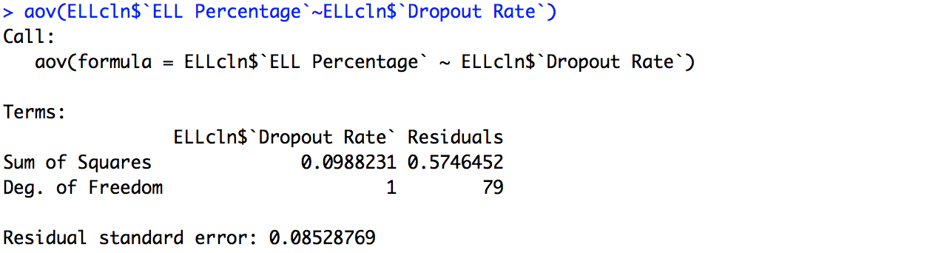

#14.)Ran the initial descriptive statistics

summary(maxmin)

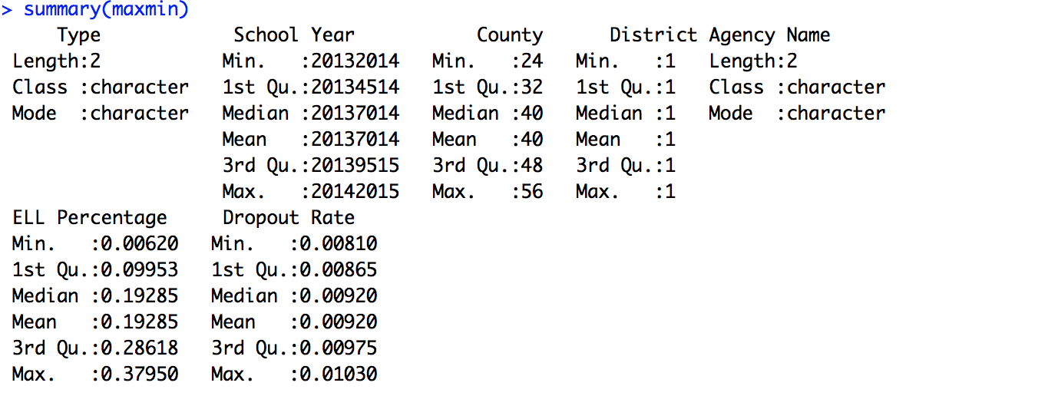

#15.) To view the fields “ELL Percentage” and “Dropout Rate”. This helps to answer the research question.

ELLcln[c("ELL Percentage","Dropout Rate")]

#16.) Create a new data frame with only these two fields.

DropRate <- ELLcln[c("ELL Percentage","Dropout Rate")]

View(DropRate)

#17.) Minimum and maximum values of “ ELL Percentage”

min(DropRate$`ELL Percentage`)

max(DropRate$`ELL Percentage`)

#18.) Minimum and maximum values of “Dropout Rate”

max(DropRate$`Dropout Rate`)

min(DropRate$`Dropout Rate`)

#19.) To get the maximum and minimum

DropRate[DropRate$`ELL Percentage` == max(DropRate$`ELL Percentage`) | DropRate$`ELL Percentage` == min(DropRate$`ELL Percentage`),]

#20.) Create a new data frame and view the data frame

Dropmaxmin <- DropRate[DropRate$`ELL Percentage` == max(DropRate$`ELL Percentage`) | DropRate$`ELL Percentage` == min(DropRate$`ELL Percentage`),]

View(Dropmaxmin)

#21.) Save the history

savehistory("~/Desktop/Nebraska education /rscript.Rhistory")